Results

## Figure 1

Relationship of bias factor $K=R^{*}/R$, linkage probability $P_{L}$, and vaccination reporting probability, given $P\left(V^{*}\right)=0.5$ and $R=0.25$.

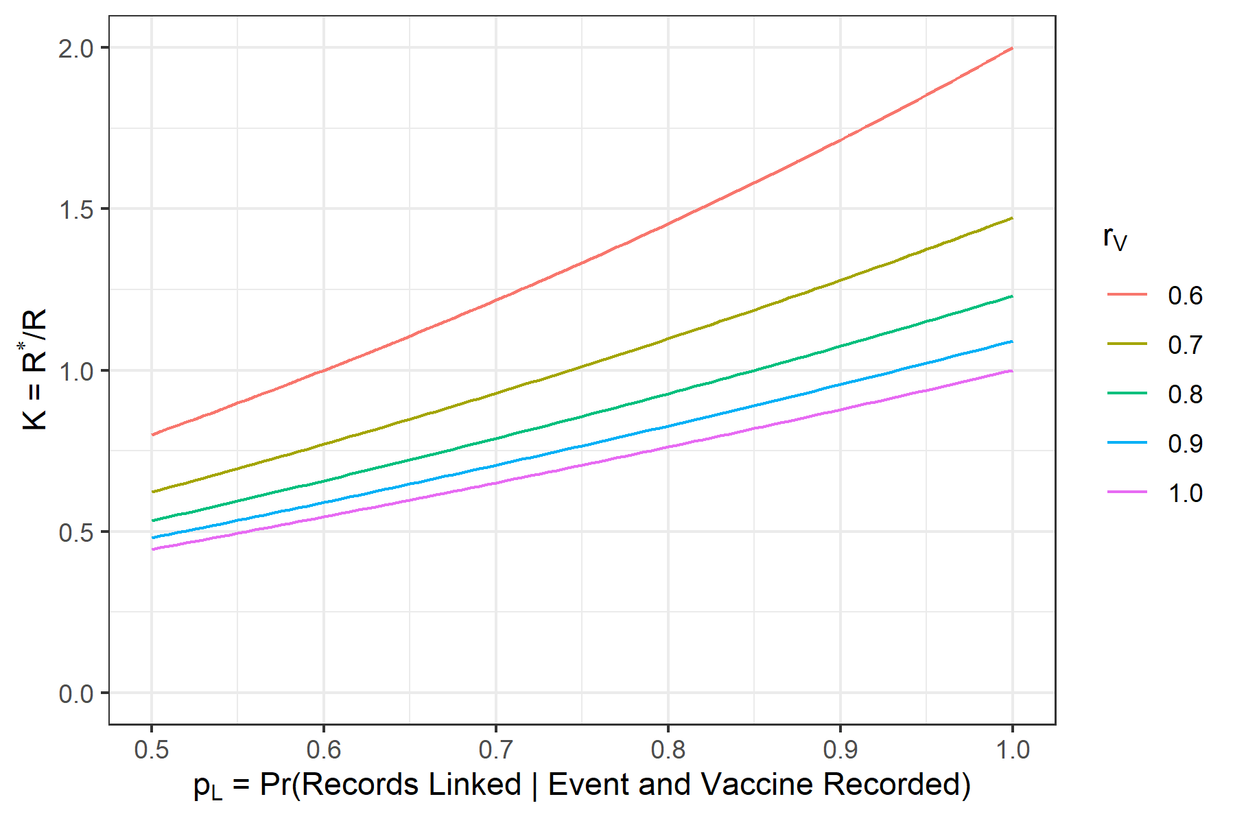

## Table 1

Simulation results with $P\left(V\right)=0.75$, $r_{D}=0.9$, $r_{V}=0.9$, and :

|  |  |  |  |  |  |  |
| --- | --- | --- | --- | --- | --- | --- |
| 1.00 | 0.95 | 0.861 | 0.861 | 0.015 | 100.0 | 100 |
| 1.00 | 0.90 | 0.745 | 0.745 | 0.013 | 100.0 | 100 |
| 1.00 | 0.70 | 0.431 | 0.431 | 0.007 | 100.0 | 100 |
| 0.25 | 0.95 | 1.114 | 1.114 | 0.029 | 0.0 | 0 |
| 0.25 | 0.90 | 1.024 | 1.024 | 0.028 | 18.1 | 8 |
| 0.25 | 0.70 | 0.712 | 0.712 | 0.020 | 100.0 | 100 |

## Table 2

Simulation results with $P\left(V\right)=0.75$, $r_{D}=0.7$, $r_{V}=0.9$, and :

|  |  |  |  |  |  |  |
| --- | --- | --- | --- | --- | --- | --- |
| 1.00 | 0.95 | 0.930 | 0.930 | 0.020 | 100.0 | 100.0 |
| 1.00 | 0.90 | 0.863 | 0.863 | 0.019 | 100.0 | 100.0 |
| 1.00 | 0.70 | 0.620 | 0.620 | 0.014 | 100.0 | 100.0 |
| 0.25 | 0.95 | 1.058 | 1.056 | 0.039 | 7.4 | 1.7 |
| 0.25 | 0.90 | 0.996 | 0.996 | 0.037 | 56.4 | 54.8 |
| 0.25 | 0.70 | 0.757 | 0.756 | 0.031 | 100.0 | 100.0 |

## Table 3

Simulation results for varying $N^{*}$ (with , , , , ):

|  |  |  |  |  |  |
| --- | --- | --- | --- | --- | --- |
| 1.20 | 13,200,000 | 1.281 | 0.050 | 0.0 | 0.0 |
| 1.10 | 12,100,000 | 1.141 | 0.043 | 0.0 | 0.0 |
| 1.05 | 11,550,000 | 1.068 | 0.041 | 4.7 | 1.1 |
| 1.00 | 11,000,000 | 0.998 | 0.036 | 51.7 | 53.4 |
| 0.95 | 10,450,000 | 0.925 | 0.034 | 98.8 | 99.8 |
| 0.90 | 9,900,000 | 0.855 | 0.032 | 100.0 | 100.0 |
| 0.80 | 8,800,000 | 0.711 | 0.026 | 100.0 | 100.0 |

Note: we haven’t worked out yet how $N^{*}≠N$ affects $K$.